Practical 9
Part A
1) | Counter race: several threads each increment a shared counter many times. Run it  without synchronization to watch the total come out too low, then make the increment  synchronized and confirm it is exactly right every run.
 | CounterRace.java
Code | public class CounterRace {  static class Counter {  int value;  void unsafe() { value++; }  synchronized void safe() { value++; }  }  static void run(boolean safe) throws InterruptedException {  Counter counter = new Counter();  Thread[] threads = new Thread[10];  for (int i = 0; i < threads.length; i++) {  threads[i] = new Thread(() -> {  for (int j = 0; j < 100000; j++) {  if (safe) { counter.safe(); } else { counter.unsafe(); }  }  });  threads[i].start();  }  for (Thread t : threads) { t.join(); }  System.out.println("Synchronized: " + safe + " Total: " + counter.value);  }  public static void main(String[] args) throws Exception { run(false); run(true); }  }
 | Race results vary; an unsafe run can occasionally produce the expected total.
Output | 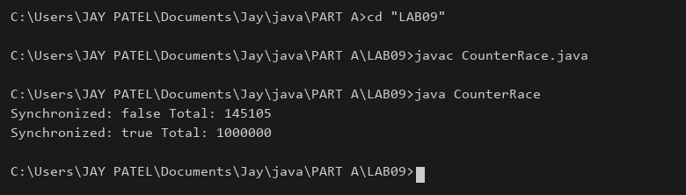

2) | Seat booking race: a shared seatsLeft of 5 with about 10 threads each trying to book one  seat. Without synchronization show that more than 5 can succeed (oversell); with a  synchronized book() exactly 5 do.
 | SeatRace.java
Code | public class SeatRace {  static class Booking {  int seatsLeft = 5;  boolean unsafe() {  if (seatsLeft > 0) {  try { Thread.sleep(10); }  catch (InterruptedException e) { Thread.currentThread().interrupt(); return false; }  seatsLeft--; return true;  }  return false;  }  synchronized boolean book() {  if (seatsLeft > 0) { seatsLeft--; return true; }  return false;  }  }  static void run(boolean safe) throws Exception {  Booking booking = new Booking();  Thread[] threads = new Thread[10];  boolean[] success = new boolean[10];  for (int i = 0; i < 10; i++) {  final int id = i;  threads[i] = new Thread(() -> {  if (safe) { success[id] = booking.book(); }  else { success[id] = booking.unsafe(); }  });  threads[i].start();  }  for (Thread t : threads) { t.join(); }  int count = 0;  for (boolean booked : success) { if (booked) { count++; } }  System.out.println("Synchronized: " + safe + " Booked: " + count);  }  public static void main(String[] args) throws Exception { run(false); run(true); }  }
Output | 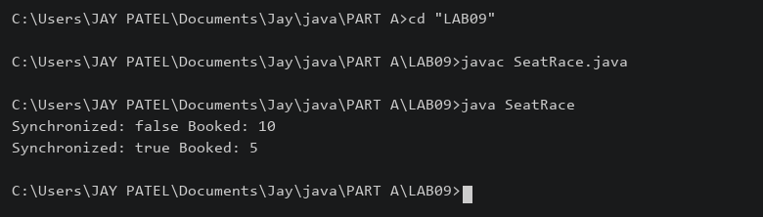

3) | (For Advanced Learners – home) Split a large array of numbers across several threads  that add into one shared total, show the wrong result, then fix it two ways and compare;  decide how to measure the difference.
 | SumDemo.java
Code | import java.util.concurrent.atomic.AtomicLong;  public class SumDemo {  static long total;  static synchronized void add(long n) { total += n; }  static void run(int mode, int[] values) throws Exception {  total = 0;  AtomicLong atomic = new AtomicLong();  Thread[] threads = new Thread[4];  long start = System.nanoTime();  for (int i = 0; i < 4; i++) {  int from = i * values.length / 4;  int to = (i + 1) * values.length / 4;  threads[i] = new Thread(() -> {  for (int j = from; j < to; j++) {  if (mode == 0) { total += values[j]; }  else if (mode == 1) { add(values[j]); }  else { atomic.addAndGet(values[j]); }  }  });  threads[i].start();  }  for (Thread t : threads) { t.join(); }  long result = total;  if (mode == 2) { result = atomic.get(); }  System.out.println("Mode " + mode + " Sum " + result  + " Time ns " + (System.nanoTime() - start));  }  public static void main(String[] args) throws Exception {  int[] values = new int[1000000];  java.util.Arrays.fill(values, 1);  run(0, values); run(1, values); run(2, values);  }  }
 | Mode 0 is unsafe; mode 1 uses synchronization; mode 2 uses AtomicLong. Times include thread creation and are illustrative.
Output | 

